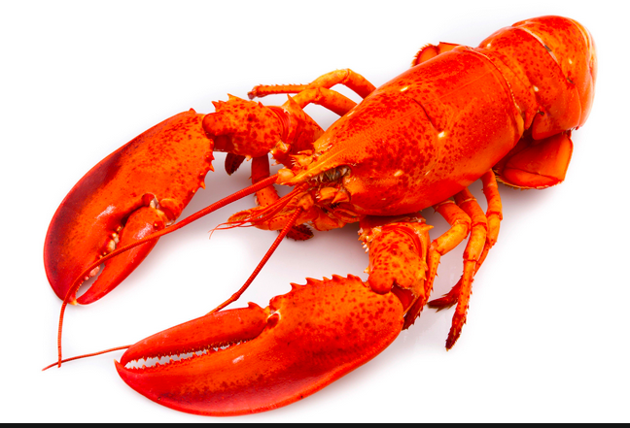

14th Annual Fall
LOBSTER

FEST

Sat. October 10, 2026

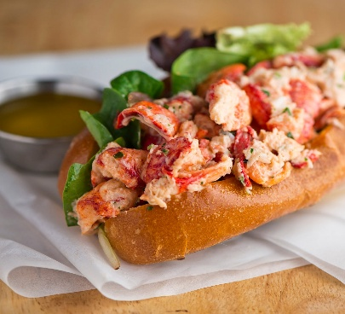
Eat In or Carry Out: 5:30 – 7:00pm
St. Andrew Presbyterian Church
10813 Donelson Drive
Williamsport, MD (Van Lear)
301-223-8887

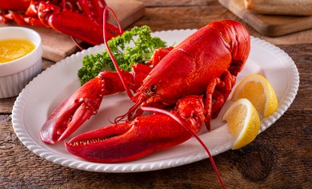
Dinner options include:
- Lobster only - whole ($45) or picked ($50)
- Lobster dinner - whole ($50) or picked ($55)
- Lobster roll dinner ($40)
- Beef brisket dinner ($35)
Full dinners include: twice-baked potato, broccoli salad, roll, and homemade dessert. Iced tea and water will be provided.
Proceeds will support St. Andrew’s Youth and Music programs.
Orders need to be received no later than Wed. Oct. 7. Call the church office (301-223-8887) or Mary Beth (301-992-2222). Pay ahead or at the door --- cash or checks only, please.

